**DOMAIN AND RANGE OF FUNCTIONS**

## 1-Polynomial Functions: f(x)=anxn+an−1xn−1+...+a2x2+a1x+a0.

|  |  |
| --- | --- |
| DOMAIN | All real number |
| RANGE | All real number |

# 2-RATIONAL FUNCTIONS F(x)= q(x)≠0

|  |  |
| --- | --- |
| DOMAIN | q(x) ≠ 0 |
| RANGE | All except the vertical asymptote |

# SQUARE ROOT FUNCTIONS

|  |  |
| --- | --- |
| DOMAIN | X ≥ 0 |
| RANGE | All real number ≥ 0 |

# Exponential function $f\left(x\right)=a^{x}$

|  |  |
| --- | --- |
| Domain | All real number |
| range | (0, +∞) all positive real number |

# Logarithms functions

Always Ln1=0

Log1=0

∞

|  |  |
| --- | --- |
| domain | x>0 |
| Range | All real number |

# Absolute value functions

F(x)= |x|

|  |  |
| --- | --- |
| domain | All real number |
| range | x≥ 0 |

NOTE:

F(x) = $\frac{2x-3}{x^{2}+4}$ domain is ($∞/-$ ∞)

**If we have two function how to compute domain?**

Example: $⁡{Ln}^{\frac{2-x}{x}}$

-**Find the domain of the rational function**

**-Combine with ln(x) restriction:**

* The domain of the rational function itself (restrictions on x for which the function is defined).علامت گذاری میکنیم
* The additional restriction of ln(x) being positive
* A white paper with black writing on it

  Description automatically generated

**Vertical asymptote**

$$X→=±value$$

F(x)→ $±∞$

**Important Notes on Vertical Asymptotes:**

* A function can have any number of vertical asymptotes.
* No polynomial function has a vertical asymptote. $x^{3}$- 3 $x^{2}$ + x - 3
* No exponential function has a v ertical asymptote. $e^{x}$
* Every logarithmic function has at least one vertical asymptote.
* Simplify the rational functions first before setting the denominator to 0 while finding the vertical asymptote

* lim x→k f(x) = ±∞ (or)
* lim x→k₊ f(x) = ±∞ (or)
* lim x→k- f(x) = ±∞

In other words, at vertical asymptote, either the left-hand side (or) the right-hand side limit of the function would be either ∞ or -∞.

Trigonometric

tan x are x = πn + π/2  
csc x are x = πn  
sec x are x = πn + 3π/2  
cot x are x = πn

-Rational To find the vertical asymptotes of a rational function, simplify it and set its denominator to zero.

Logarithmic x=0

* To find the vertical asymptotes of logarithmic function f(x) = log (ax + b), set ax + b = 0 and solve for x.

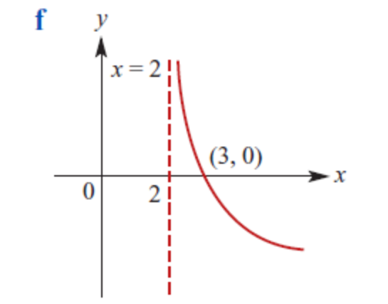

# **Horizontal asymptotes**

# **x→ $±∞$**

# **f(x)→c values**

* it’s a line parallel to the x-axis that the function’s curve appears to get closer to but never actually intersects.
* The HA helps us understand the end behavior of the function
* Compute limits x→∞
* If the limits result in (\infty) or (-\infty), ignore them; they are not the H
* When the degree of the numerator of a rational function is **less** than the degree of the denominator, the x-axis (y = 0) serves as the HA.
* When the degree of the numerator is **greater** than the degree of the denominator, there is no HA.
* **do not have a horizontal asymptote**
* logarithms
* polynomial

-rational functions $\frac{X}{Y}$ 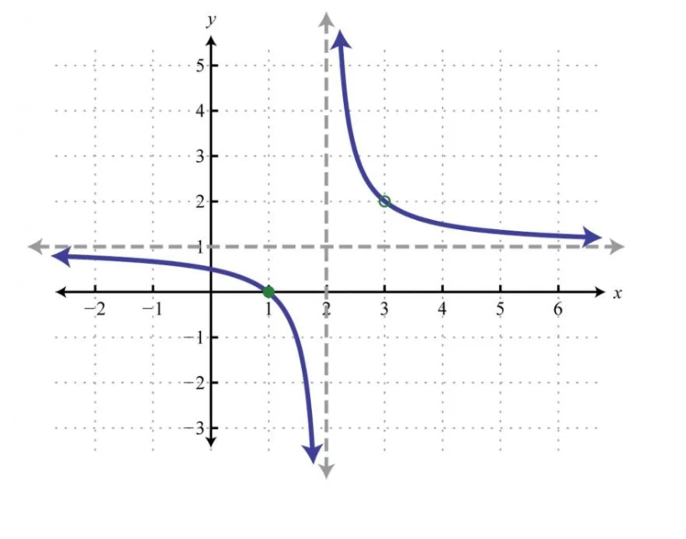

-xponential functions

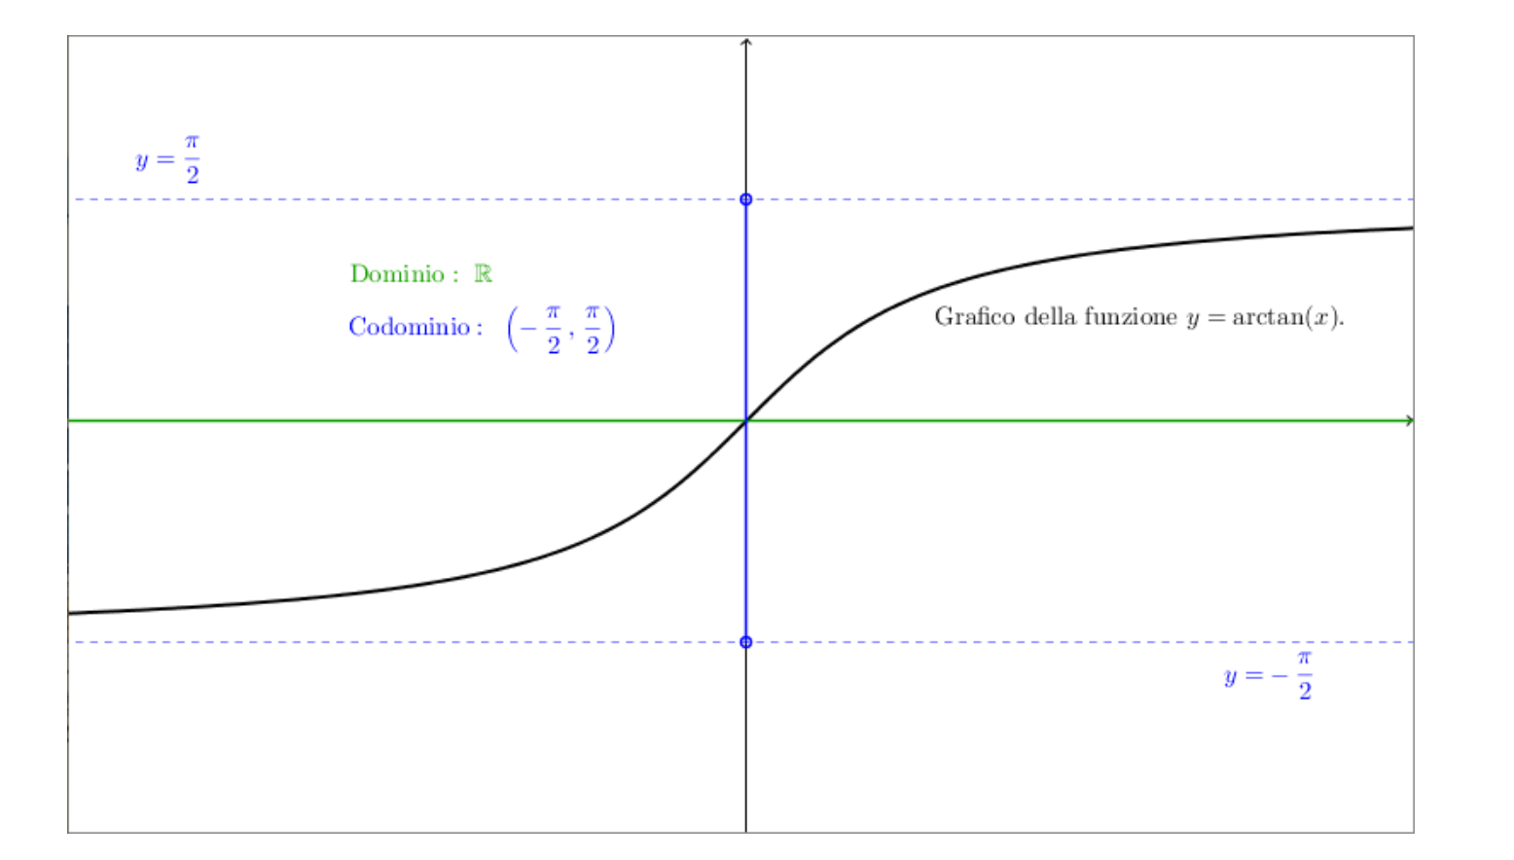

**Oblique asymptote**

**when the degree of the numerator (n) is exactly one greater than the degree of the denominator (m)**

example:

consider the function f(x) = (2x^2 + 3x) / (x - 1).

* Degree of numerator (n) = 2
* Degree of denominator (m) = 1

Since n (2) is exactly one greater than m (1), this function has an oblique asymptote

Dividing the numerator by the denominator results in a quotient of 2x + 5 and a remainder of 8.

|  |
| --- |
| (y = mx + b) |
| oblique asymptote is y = 2x + 5. |

**Local Maximum and minimum**

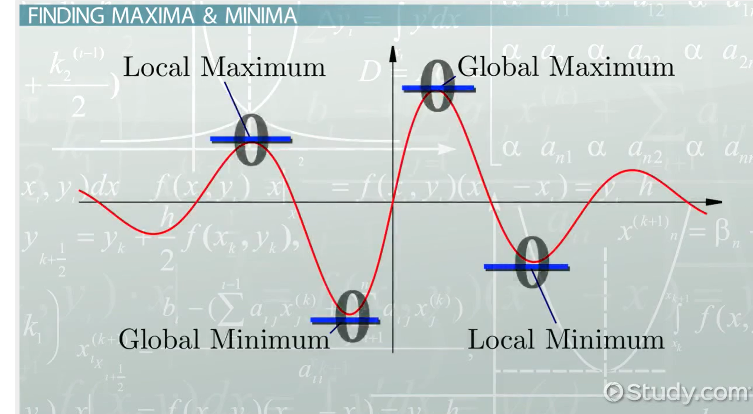

**Methods to Find Local Maximum and Minimum:**

* + We can identify local maxima and minima by taking the **derivative** of the given function.
  + Two important methods are used:
    - **First Derivative Test**: Analyzes turning points where the function output has a maximum or minimum value.
    - **Second Derivative Test**: Examines the concavity of the function to determine extrema.
  + A diagram of a function

    Description automatically generated A diagram of a positive and negative gradient

    Description automatically generated
* If (f’(x)) changes sign from positive to negative as (x) increases through a critical point (c), then (c) is a point of **local maxima**.
* If (f’(x)) changes sign from negative to positive as (x) increases through (c), then (c) is a point of **local minima**

**How to compute functions(sometimes after derivative we have to compute x so we have :**

|  |  |
| --- | --- |
| Discriminant | Number of Roots |
| Δ>0 | Two distinct real roots |
| Δ=0 | One real root (double root) |
| Δ<0 | No real roots |

*x*= $\frac{-b±√∆}{2a}$ if Δ>0

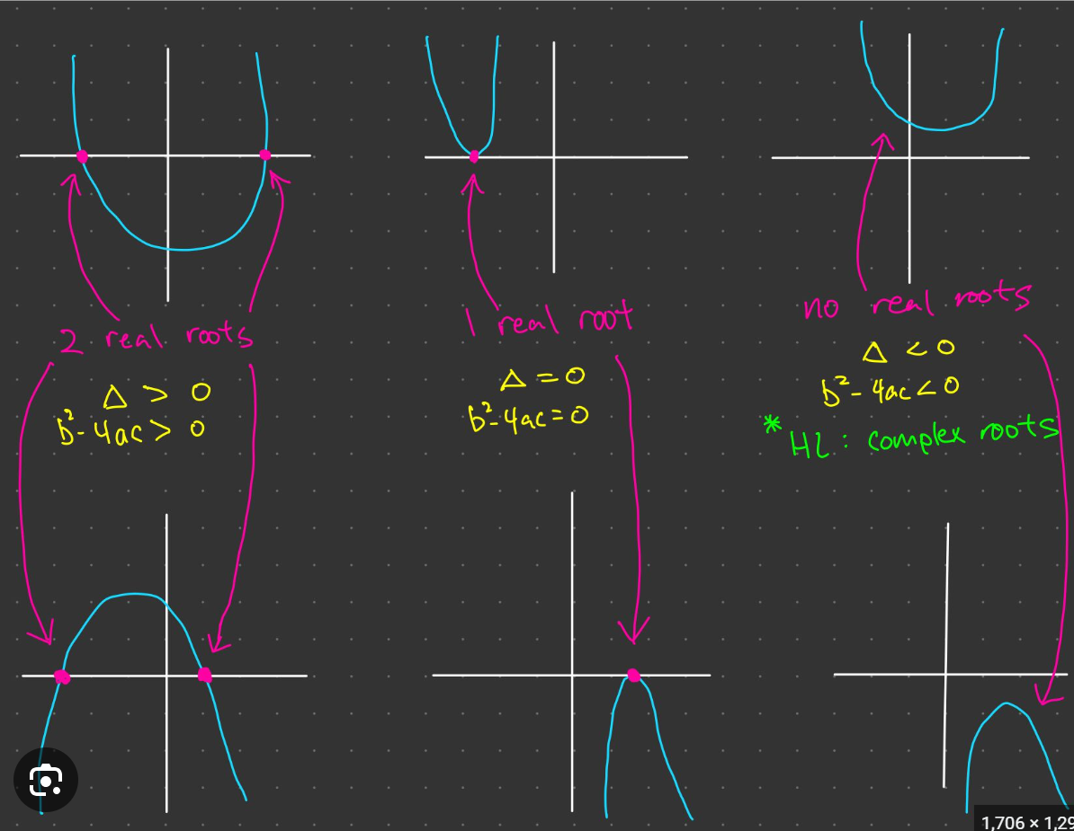

**DERIVATIVE formulas**

Ln(U)’=

Log(1) in any base=1

Ln=log in base of e which e = 2.7

Neper number = e

How to draw graph for function

|  |
| --- |
| Y=0 ( , 0 ) |
| X=0 ( 0, ) |
| F’(x) = 0 بدست بیاد y بعد از اینکه بدست اوردیم نقاط محلی را در تابع اصلی میزاریم تا نقطه |
| F’(x) = 0 علامت یابی برای بدست اوردن ماکس مینیموم محلی  قبل و بعد از عدد بدست اورده را مبزاریم توی تابع و به + - نگاه میکنیم و شکل رسم میکنیم |

-3x

Example

|  |  |  |  |  |  |
| --- | --- | --- | --- | --- | --- |
| x | - | 0 |  | 2 | + |
| G(x)=x | - |  | + |  | + |
| H(x)=x-2 | - |  | - |  | + |
| F(x)=G(x)/H(x) | + |  | - |  | + |
| Ln(F(x)) | *********************** |  |  |  | ********************* |

Properly and improperly integrable

Properly integrable = there is no asymptote point in the interval of integration

Improperly integrable = there is at a asymptote point in the interval of integration

For example consider f(x)= $\frac{(x+2)}{x^{2}-1}$

This function has two vertical asymptotes in x=-1 and x=1

 So if the interval of the question consists of one of these points, the function is improperly integrable

But if the interval of integral does not consist of the vertical asymptote points, the function is properly integrable.

Ex1= integral of f(x) in [0,+inf) is improperly integrable

Ex1p=integral of f(x) in (1,+inf) is properly integrable

 Ex2= integral of f(x) in [1,+inf) is improperly integrable

Ex3= integral of f(x) in (-inf,0] is improperly integrable

Ex4= integral of f(x) in (-inf,-1] is improperly integrable

 Ex= integral of f(x) in [3,+inf] is properly integrable

-Properly in [2,∞)









Critical point

Derivative =0

|  |  |
| --- | --- |
|  |  |
| Determinant>0 | $fxx$ >0 minimum if fxx<0 maximum |
| Determinant=0 |  |
| Determinant<0 | saddle point |